Giles Chemical, a division of Premier Magnesia, LLC is dedicated to providing a safe working environment to employees and the general public

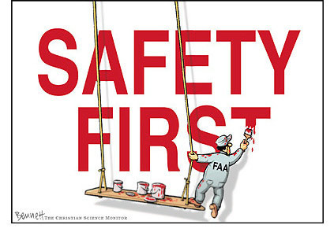

SAFETY HANDBOOK

The most important part of safety is YOU. It is up to you to abide by the safety rules—they are made for your protection. You are expected to report any personal injury IMMEDIATELY, however minor, and all dangerous conditions, substances and practices to your supervisor.

Certain safety screenings, testing, and training will be considered a mandatory requirement for continued employment. Failure to attend scheduled training sessions and screenings can result in termination of employment.

SAFETY
- Employees must follow all safety rules and procedures.
- Each employee must accept responsibility for his or her own safety.
- Discuss safety concerns with a representative from the Safety Department or any other member of Management.
- Suggestions for any ideas to improve safety are always encouraged.
- Safety is a condition of employment. Employees are not authorized to work in an unsafe manner and are prohibited from harming the environment of the facility or community.
- Violation of safety rules and/or procedures can lead up to and including dismissal.

SAFETY MEETINGS
- Giles has monthly operator meetings where safety items are discussed:
-Monthly and Yearly Safety Statistics
-Safety Incidents
-Safety improvements are discussed
-Safety Training/Video and quiz
- Giles complies a monthly Operations Report for upper Management including:
-Monthly and Yearly Safety Statistics
-Safety Incidents
-Safety Initiatives
-Safety Projects that are in place and future safety projects

REPORTING INJURIES

- All incidents and injuries must be reported immediately to Supervisor or Production Manager. Supervisors and Managers must in turn report to Safety Department and Human Resources.
- A detailed Accident/Injury Report will be completed.
- Failure to report an injury, no matter how minor, can result in disciplinary action and lead to termination.
EMERGENCY RESPONSE TEAM (ERT) 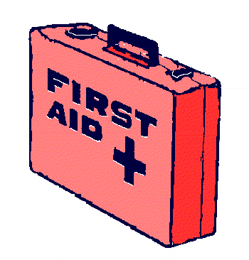

- Giles has an Emergency Response Team that is available to aid an employee in the event of a safety incident. Team members are certified in CPR and First Aid. Giles ERT consists of several employees throughout the facilities; their names are posted on bulletin boards in designated areas. Though Giles has an ERT; 911 is always an option for any employee if they feel it is necessary.

HORSEPLAY and FIGHTING

- Horseplay and fighting are strictly prohibited; disciplinary action will be taken up to and including discharge.

SAFETY and HOUSEKEEPING AUDITS

- Weekly Safety and Housekeeping Audits are performed by Management with assistance from operators.
- Audit results are posted for one week listing corrective actions.



EMERGENCY EXITS and LIGHTS

- All Emergency Exits are marked with Emergency Exit signs and Emergency Exit Lights, which are inspected quarterly to ensure lights and signs are working properly.

FIRE EXTINGUISHERS

- All Giles facilities are equipped with Fire Extinguishers.
- Fire Extinguishers are inspected annually by contracted vendor.
- Fire Extinguishers are inspected monthly internally and findings are recorded.
- Fire Extinguishers that do not pass inspection must be reported to the Safety Department.
- Replacement or recharging of Fire Extinguishers will be performed by contracted vendor.

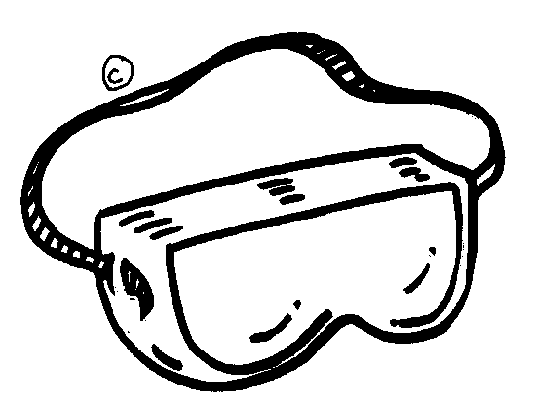

PERSONAL PROTECTIVE EQUIMPMENT (PPE)

- All Giles employees are required to wear safety glasses and steel toe shoes while in production areas.
- Office personal are required to wear safety glasses in production area but must stay in the designated safety zone. Office personal are not required to wear steel toe shoes in safety zone but must wear closed-toed flat shoes (No heels allowed in production areas).
- Safety attire such as acid suit, harness, gloves, etc. must be worn as defined by the respective procedure.
- Employees are responsible for the proper care and storage of their PPE.

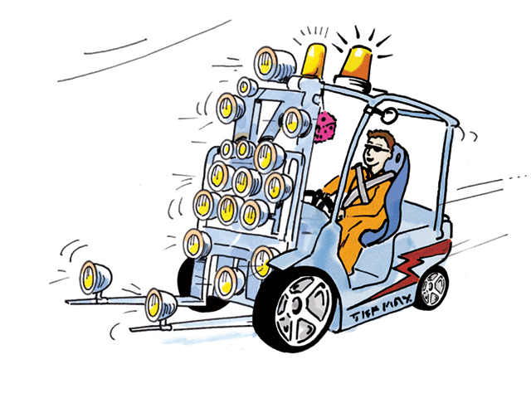

FORKLIFTS

- No employee shall operate a Forklift without current certification.
- Re-certification for forklift operators will be performed every 2 years as required by OSHA.
- All employees are expected to follow OSHA guidelines.
- Operators will perform daily forklift inspections on each shift. If there is any problem with a forklift it must be immediately reported to Maintenance and/or Safety Department.
- Remember when operating a forklift to always be aware of pedestrians.
- Do not operate forklifts at excessive speed.
- In the event that an employee has an incident with a forklift, the employee will be retrained to ensure employee is aware how to properly operate forklift.
- Unsafe actions on a forklift can result in disciplinary action and can lead to termination.

LADDER INSPECTIONS

- All ladders are checked and tagged on a quarterly basis to ensure the integrity of the ladder.
- It is the responsibility of the employee to ensure the ladder is safe.
- Ladders that do not pass inspection are taken out of use and are demolished so there is no risk of the ladder being used again.
- If there is a problem with the ladder, tag the ladder and report to Maintenance.
- After using the ladder please put it back where it belongs.

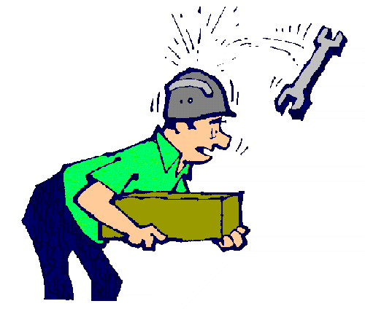

OVERHEAD WORK

- When maintenance work is being performed overhead, all areas under working area must be barricaded to ensure no employee walks in that area.
- Employees must wear safety harness and tie off when working over head and in areas without safety railing and catwalks.

SAFETY SHOWERS and EYE WASH STATIONS

- Plants are equipped with Safety Showers and Eye Wash stations depending on need.
- Safety Showers and Eye Wash stations are to be checked daily and recorded at the beginning of each shift.
- Record any problems with Safety Showers or Eye Wash stations on tag.
- Report any problems with Safety Showers or Eye Wash stations to the Safety Department.

CONFINED SPACE ENTRY

- Giles has a Confined Space Procedure.
- All safety precautions are to be followed as defined by the procedure.

LOCK-OUT, TAG-OUT

- Giles has a Lock-Out, Tag-Out Program including training.
- All equipment must be Locked Out before work is performed.
- All safety precautions are to be followed as defined by the program.

SECURITY

- If an employee suspects an unauthorized person on facility grounds, he or she shall be reported immediately to a Supervisor and/or Plant Manager.

